# Explain the term Financial Management. How the goal of wealth maximization is better than profit maximization?

Financial Management is that managerial activity which is concerned with the planning and controlling of the firm's financial resources.

1. It is a long-term strategy which emphasizes on raising the present value of the owner's investment in a company and the implementation of projects that will increase the market value of the firm's securities.
2. Recognizes the risk or uncertainty
3. Recognizes the timing of returns by considering the trade-off between the various returns and the associated levels of risk.
4. Considers the shareholders return by considering the payment of dividend to shareholders.

# Beta is Measurement of Market Risk. Explain

The sensitivity of a security to market movements is called beta .

Beta reflects the slope of a linear regression relationship between the return on the security and the return on the portfolio.

# Explain the term working capital management. State the factors that impact [**working capital requirement?**](https://www.careerride.com/fa-factors-affecting-working-capital-requirement.aspx) Explain its determinants.

Working capital management ensures the best utilisation of a business's current assets and liabilities for the company's effective operation. The main aim of managing working capital is to monitor a company's assets and liabilities to maintain adequate cash flow and meet short-term business goals

**Factors affecting working capital requirement:**  
  
1) Nature of business  
  
2) Size of the organization  
  
3) Phase of trade cycles  
  
4) Production policies  
  
5) Turnover of inventories  
  
6) Dividend Policies  
  
7) Trading terms  
  
8) Length of production cycle  
  
9) Profitability  
  
10) Seasonal Variations.

# Explain the term receivables management. What are its objectives? State important dimensions of a firm’s credit policy?

Management of receivables refers to planning and controlling of debt owed to the customer on account of credit sales. In simple words, the successful closure of your order to sales is determined only when you convert your sales into cash.

Objectives of Receivable Management:

* Creating, presenting and collecting in accounts receivables.
* In order to establish and communicate he credit policies.
* For evaluation of customers and setting credit limits.
* In order to ensure prompt and accurate billing.
* To maintain up-to —date record of accounts receivables.
* To initiate collection procedures on overdue accounts.

The important dimensions of a firm’s credit policy are:

* Credit standards

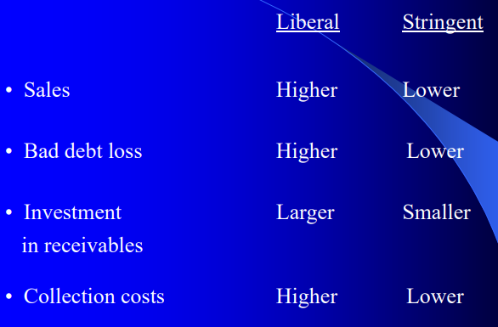

* Credit period

* Cash discount
* Collection effort

# How are techniques of Capital Budgeting classified? List down the techniques under each classification and explain them.

NET PRESENT VALUE

BENEFIT COST RATIO

INTERNAL RATE OF RETURN

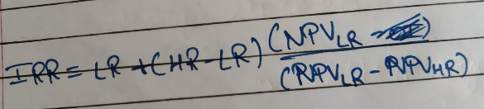

# Explain advantages and disadvantages of each of the techniques of capital budgeting?

**Pros**

* Helps you compare different kinds of projects along the same metrics to make the best decisions based on data
* Gives you a number of different techniques to use to make wise investments
* Enables you to deliver more value to stakeholders by increasing the chances you make the best decisions

**Cons**

* Can give you false security because you are dealing with hypotheticals; if a project gets delayed or runs over budget, what good are your calculations?
* When you make a decision, the implications can be significant; the wrong decision could seriously hurt your organization
* Finding skilled accountants with bandwidth to make these calculations can be a tall order—and a pricey endeavor

# Define Diversification of portfolio? Explain the relationship between Diversification and Risk.

Diversification is the practice of spreading your investments around so that your exposure to any one type of asset is limited. This practice is designed to help reduce the volatility of your portfolio over time.

A company spreads its risks by selling a varied product range, operating in different markets, or selling in many countries.

Investors create a diversified portfolio of assets, so the specific risk associated with one asset is offset by the specific risk associated with another asset.

# Explain how the scope of finance function changed overtime. What role finance managers play in a modern finance?

Financial Management is all about planning, organizing, directing, and controlling the economic pursuits such as acquisition and utilization of capital of the firm. To put it in other words, it is applying general management standards to the financial resources of the firm.

To understand the financial management scope, first, it is essential to understand the approaches that are divided into two sections.

1. Traditional Approach

During the 20th century, the traditional approach was also known as corporate finance. This approach was initiated to procure and manage funds for the company. For studying financial management, the following three points were used

(i) Institutional sources of finance.

(ii) Issue of financial devices to collect refunds from the capital market.

(iii) Accounting and legal relationship l between the source of finance and business.

In this approach, finance was required not for regular business operations but occasional events like reorganization, promotion, liquidation, expansion, etc. It was considered essential to have funds for such events and regarded as one of the crucial functions of a financial manager.

### Limitations of Traditional Approach

* **One-sided approach-**It is more considerate towards the fund procurement and the issues related to their administration, however, it pays no attention to the effective utilization of funds.
* **Gives importance to the Financial Problems of Corporations-** It only focuses on the financial problems of corporate enterprises, so it narrows the opportunity of the finance function.
* **Attention to Irregular Events-**It provides funds to irregular events like consolidation, incorporation, reorganization, and mergers, etc. and does not give attention to everyday business operations.
* **More Emphasis on Long Term Funds-** It deals with the issues of long-term financing.

1. Modern Approach

With technological improvement, increase competition, and the development of strong corporate, it was important for Management to use the available financial resources in its best possible way. Therefore, the traditional approach became inefficient in a growing business environment.

The modern approach had a more comprehensive analytical viewpoint with a focus on the procurement of funds and its active and optimum use. The fund arrangement is an essential feature of the entire finance function.

The main elements of this approach are an evaluation of alternative utilisation of funds, capital budgeting, financial planning, ascertainment of financial standards for the business success, determination of cost of capital, working capital management, Management of income, etc. The three critical decisions taken under this approach are.

(i) Investment Decision

(ii) Financing Decision

(iii) Dividend Decision

Features of Modern Approach

The following are the main features of a modern approach.

* **More Emphasis on Financial Decisions-**This approach is more analytic and less descriptive as the right decisions for a business can be taken only on the base of accounting and statistical data.
* **Continuous Function-**The modern approach is a constant activity where the financial manager makes different financing decisions unlike the traditional method,
* **Broader View-**It gives importance not only to optimum use of finance also abut the fund’s procurement. Similarly, it also incorporates features relating to the cost of capital, capital budgeting, and financial planning, etc.
* **The measure of Performance-**Performance of a firm is also affected by the financial decision taken by the Management or finance manager. Therefore, to maximize revenue, the modern approach keeps a balance between liquidity and profitability.

## **Roles of Financial Management:**

* Taking part in utilising the funds and controlling productivity.
* Recognizing the requisites of capital (funds) and picking up the sources for that capital.
* Investment accords incorporate investment in fixed assets known as capital budgeting. Investing in current assets are part and parcel of investment decisions known as working capital decisions.
* Financial decisions associated with the finance raised from different sources which would rely upon the accord on – the kind of resource, when is the financing done, cost incurred and the returns as well.
* In the case of dividend decision, the finance manager is the who is responsible for the accord that is taken by him or her; regarding the net profit distribution (NPD). However, Net profits are classified into two(2) types:

1. Dividend for shareholders: The rate of dividend and the amount of dividend has to be decided
2. Retained profits: The amount of contained (retained) gains has to be ascertained which would rely upon the development and variety of strategies of the trading concern

# Distinguish between Diversifiable Risk and Non-Diversifiable Risk, Unique Risk and Market Risk, Systematic risk, and Unsystematic risk.

**Diversifiable Risk and Non-Diversifiable Risk**

Diversifiable risk is also called as "unsystematic risk". These risks are the risk of price change because of unique features of the particular security. Systematic risks are independent of the overall market conditions. Diversifiable risk can be partially or entirely eliminated by diversification of the portfolio.

Non-diversifiable risk is also known as "systemic risk" or "market risk", as the risks are concerned with the market conditions. The notable factor to consider is that the total risk, non-diversifiable risk, and diversifiable risk are related to each other because the non-diversifiable and diversifiable risks are part of "total risk".

**Unique Risk and Market Risk**

Unique risk of a security represents that portion of its total risk which stems from company-specific factors.

Market risk of security represents that portion of its risk which is attributable to economy —wide factors.

**Systematic risk and Unsystematic risk**

By the term ‘systematic risk’, we mean the variation in the returns on securities, arising due to macroeconomic factors of business such as social, political or economic factors. Such fluctuations are related to the changes in the return of the entire market. Systematic risk is caused by the changes in government policy, the act of nature such as natural disaster, changes in the nation’s economy, international economic components, etc. The risk may result in the fall of the value of investments over a period. It is divided into three categories, that are explained as under:

* **Interest risk**: Risk caused by the fluctuation in the rate or interest from time to time and affects interest-bearing securities like bonds and debentures.
* **Inflation risk**: Alternatively known as purchasing power risk as it adversely affects the purchasing power of an individual. Such risk arises due to a rise in the cost of production, the rise in wages, etc.
* **Market risk**: The risk influences the prices of a share, i.e. the prices will rise or fall consistently over a period along with other shares of the market.

The risk arising due to the fluctuations in returns of a company’s security due to the micro-economic factors, i.e. factors existing in the organization, is known as unsystematic risk. The factors that cause such risk relates to a particular security of a company or industry so influences a particular organization only. The risk can be avoided by the organization if necessary actions are taken in this regard. It has been divided into two category business risk and financial risk, explained as under:

* **Business risk:** Risk inherent to the securities, is the company may or may not perform well. The risk when a company performs below average is known as a business risk. There are some factors that cause business risks like changes in government policies, the rise in competition, change in consumer taste and preferences, development of substitute products, technological changes, etc.
* **Financial risk**: Alternatively known as leveraged risk. When there is a change in the capital structure of the company, it amounts to a financial risk. The debt – equity ratio is the expression of such risk.

# Differentiate between operating, financial, and combined leverage.

| **BASIS FOR COMPARISON** | **OPERATING LEVERAGE** | **FINANCIAL LEVERAGE** |
| --- | --- | --- |
| Meaning | Use of such assets in the company's operations for which it has to pay fixed costs is known as Operating Leverage. | Use of debt in a company's capital structure for which it has to pay interest expenses is known as Financial Leverage. |
| Measures | Effect of Fixed operating costs. | Effect of Interest expenses |
| Relates | Sales and EBIT | EBIT and EPS |
| Ascertained by | Company's Cost Structure | Company's Capital Structure |
| Preferable | Low | High, only when ROCE is higher |
| Formula | DOL = Contribution / EBIT | DFL = EBIT / EBT |
| Risk | It give rise to business risk. | It give rise to financial risk. |

# Cost of capital is affected by various Factors. Explain

Factors outside a Firm’s control:

1. The Level of Interest rates: If interest rates in the economy rise, the cost of debt to firms increases and vice versa. Interest rates also have similar bearing on the cost of preference and cost of equity.

2. Market Risk Premium: The market risk premium reflects the perceived riskiness of equity stocks and investor aversion of risk. The market risk premium affects the cost of equity directly and the cost of debt indirectly (through a substitution effect)

3. Tax Rates: The tax policy of the Government has a bearing on cost of capital. The corporate tax rate has a direct impact on the cost of debt as used in the weighted average cost of capital. The capital gains tax rate relative to the rate an ordinary income has an indirect effect on the cost of equity relative to cost of debt.

Factors within Firm’s Control:

1. Investment Policy: If a firm plans to invest in assets similar to those currently used, then its marginal cost of capital would be more or less the same as its current cost of capital. On the other hand, if the riskiness of its proposed investments is likely to be very different from the riskiness of its existing investments, its marginal cost of capital should reflect the riskiness of the proposed investments.
2. Capital structure policy: Firm can change its capital structure and such a change is likely to affect the cost of capital because the post – tax cost of debt is lower than the cost of equity.
3. Dividend Policy: The dividend policy of a firm may affect its cost of equity.

# Explain relationship between certainty equivalent and expected value from the risky investment.

The relationship of a person's certainty equivalent to the expected monetary value of a risky investment defines his attitude toward risk. If the certainty equivalent is less than the expected value, the person is risk averse; if the certainty equivalent is equal to the expected value, the person is risk-neutral; finally, if the certainty equivalent is more than the expected value, the person is risk-loving.

In general, investors are risk averse. This means that risky investments must offer higher expected returns than less risky investments to induce people to invest in them. Remember, however, that we are talking about expected returns; the actual return on a risky investment may well turn out to be less than the actual return on a less risky investment.

Put differently, risk and return go hand in hand. This indeed is a well-established empirical fact, particularly over long periods of time.

# what are the functions performed by finance manager.

Finance function may be classified into two groups:

1. Executive finance function — which requires administrative in planning and exeution.
2. Incidental finance function — for the most part it covers routine work, chiefly clerical, that is to carry into effect financial at the executive level.

# Explain Indifference Analysis.

Indifference point EBIT level beyond which benefits of financial leverage accrue with respect to EPS. The indifference point between two methods of financing can be obtained mathematically (algebraic approach) as well as graphically.

Algebraic Approach

Mathematically, the indifference point can be obtained by using the following

symbols:

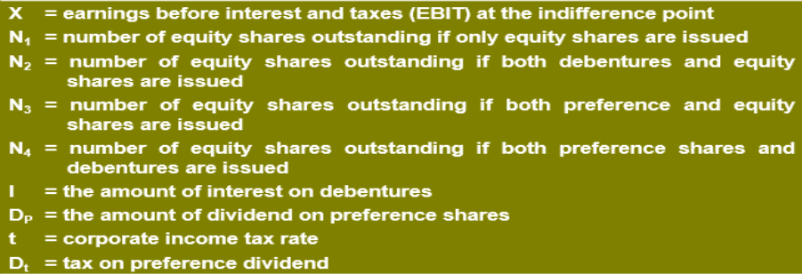

# What is Beta? Explain the relationship of Beta with Expected Returns.

The beta (β) of an investment security (i.e., a stock) is a measurement of its volatility of returns relative to the entire market. It is used as a measure of risk and is an integral part of the Capital Asset Pricing Model ([CAPM](https://corporatefinanceinstitute.com/resources/knowledge/finance/what-is-capm-formula/)). A company with a higher beta has greater risk and also greater expected returns.

The beta coefficient can be interpreted as follows:

* β =1 exactly as volatile as the market
* β >1 more volatile than the market
* β <1>0 less volatile than the market
* β =0 uncorrelated to the market
* β <0 negatively correlated to the market

 the expected rate of return on an investment is directly proportional to its risk premium, as signified by its beta.

# State the relation between risk aversion and required returns

The relationship of a person's certainty equivalent to the expected monetary value of a risky investment defines his attitude toward risk. If the certainty equivalent is less than the expected value, the person is risk averse; if the certainty equivalent is equal to the expected value, the person is risk-neutral; finally, if the certainty equivalent is more than the expected value, the person is risk-loving.

In general, investors are risk averse. This means that risky investments must offer higher expected returns than less risky investments to induce people to invest in them. Remember, however, that we are talking about expected returns; the actual return on a risky investment may well turn out to be less than the actual return on a less risky investment. Put differently, risk and return go hand in hand. This indeed is a well-established empirical fact, particularly over long periods of time.

# Explain various approaches to estimate cost of equity.

* Security Market Line Approach

***rE* = *Rf* + *βE* [*E*(*RM*) – *Rf* ]**

***rE* = required return on the equity of the company**

***Rf* = risk-free rate**

***βE* = beta of the equity of the company**

***E*(*RM*) = expected return on the market portfolio**

* Bond Yield Plus Risk Premium Approach
* Dividend Growth Model Approach

Thus, the expected return of equity shareholders, which in equilibrium is also the required return, is equal to the dividend yield plus the expected growth rate

* Earnings-Price Ratio Approach

**Cost of equity = E1 / PO**

**where E1 = the expected EPS for the next year**

**PO = the current market price**

# What is Annuity? What is the difference between deferred annuity and annuity due?

Thus annuity can be defined as a sequence of periodic payments (or receipts) regularly over a specified period of time. Annuity may be of two types:

(1) Annuity regular: In annuity regular first payment/receipt takes place at the end of first

We can see that first payment/ receipts takes place at the end of first year therefore it is an annuity regular.

(2) Annuity Due or Annuity Immediate: When the first receipt or payment is made today (at the beginning of the annuity) it is called annuity due or annuity immediate. Consider following table:

We can see that first receipt or payment is made in the beginning of the first year. This type

of annuity is called annuity due or annuity immediate.

# Explain Liquidation value, Going concern value, Book value, Market value Intrinsic value?

**The liquidation values**

Amount that can be realized when an asset, or a group of assets representing a part or even the whole a firm, is sold separately from the operating organization to which it belongs.

**The going concern value**

The amount that can be realized if the firm is sold as a continuing operating entity.

**Book Value**

The book value of an asset is the accounting value of the asset, which is simply the historical cost of the asset less accumulated depreciation or amortization. The book value of a firm's equity is equal to the book value of its assets minus the book value of its liabilities. Because book value reflects a historical accounting value it may diverge significantly from market value.

**Market Value**

the market value of a security is the price at which the security trades in the financial market.

**Intrinsic Value**

The intrinsic value of a security is the present value of the cashflow stream expected from the security discounted at a rate of return appropriate for the risk associated with the security.

# What are bonds? Explain different types of bonds in the market and List their features.

A bond represents a contract under which a borrower promises to pay interest and principal on a specific dates to the holders of the bond.

The various types of bonds include:

### Fixed-rate bonds

Fixed-rate bonds pay consistent interest amounts until maturity. The bondholders earn predictable and guaranteed returns regardless of the prevailing market conditions.

For example, An investor purchased a ten-year fixed-rate government bond of Rs. 1000, issued on 20th April 2013 which offers a coupon rate of 7.5%. The investor will get a fixed interest of Rs. 75, annually every April, till 20th April 2023.

### Floating-rate bonds

Floating-rate bonds do not pay fixed returns each period. Instead, the interest rates vary, depending on the set benchmark, during the tenure.

For example, an investor purchased an 8-year floating rate bond issued in 2015. The bond pays interest of 40 points higher than the prevailing National Savings Certificate interest rate. This means the NSC interest rate is the benchmark and any fluctuation in it directly affects the coupon payment of this bond.

### Zero-coupon bonds

As the name implies, these bonds do not pay periodic coupons during their tenure. Though, these bonds are issued at a discount and repayable at the par value. The difference is the yield for investors.

For example, an investor buys a 20-year zero-coupon bond, with a face value of Rs. 1000, at Rs. 700. At the end of 20 years, the issuer will pay Rs. 1000 to the bondholder.

### Perpetual bonds

Perpetual bonds are those debt securities which do not have a maturity. In this type of bond, the issuer does not repay the principal amount to the bondholders. Though, they keep paying steady coupon payments to the bondholders till perpetuity.

### Inflation-linked bonds

These types of bonds aim at minimizing the impact of inflation on the face value and coupon payments. The principal is adjusted according to the inflation and coupon payments are made based on the adjusted principal.

For example, an investor purchases an Inflation-linked bond with a face value of Rs. 100. After a year, the inflation-adjusted principal amounts to Rs. 107. Therefore, the coupon will be paid considering Rs. 107 for that period.

### Convertible Bonds

The investors holding convertible bonds get the right to convert the bond to a predefined number of equity shares in the issuing company at a particular time from the tenure. Though, the investor can also opt to receive the principal repayment at the maturity, if they don’t want to exchange it with shares.

### Callable Bonds

Callable bonds are high coupon paying securities that give the issuer the right to call back the bonds at a pre-agreed price and date.

### Puttable Bonds

Puttable bonds give the bondholder the right to return the bond and ask for repayment of principal at a pre-agreed date before maturity. Since the benefit offered is for investors, these bonds pay lower returns.

## **Features of Bonds**

The key features of bonds are as follows.

* **Issuer:**Bond issuers borrow money from investors against bonds. Commonly found bond issuers are the government, government institutions, municipalities, and corporations.
* **Face Value:**The face or par value of the bond is the price of a bond repayable at maturity. This price may differ from the bond price prevailing in the secondary market.
* **Coupon rate:** The issuer of the bonds compensates the bondholders by paying them interest. The rate of interest or coupon payment varies depending upon the economic circumstances, the creditworthiness of the issuer, type of bond, maturity, etc.
* **Maturity:**Except for perpetuity bonds, all the bondholders get repaid at a specific date when the bonds get matured. The bonds are categorized as short-term or long-term bonds based on their maturity date.
* **Credit rating:**Each bond holds the rating, provided by credit rating agencies. A higher rating suggests a lower amount of risk and lower yields. If the rating is lower, the risk involved in the bond is higher along with higher returns.
* **Yield:** Yield means the return investor gets from the bond for a specific time. If the bond is held till maturity, the return is termed as yield to maturity. The yield can be calculated considering the face value, annual interest, maturity, and the market price of the bond.

# Explain bond terminologies. How are Bond prices, Coupon and YTM related.

Terminology: in order to understand the valuation of bonds, we need familiarity with certain

bond related terms.

**Par value** This is the value stated on the face of the bond. It represents the amount the firm

borrows and promises to repay at the time of maturity. Usually, the par or face value of bonds

issued by business firms is 100. Sometimes it is 1,000.

**Coupon Rate and Interest** A bond carries a specific interest rate which is called 'the coupon rate'.

The interest payable to the bond holder is simply: par value of the bond x coupon rate. Most

bonds pay interest semi-annually. For example, a government security which has a par value

of 1,000 and a coupon rate of 11 percent pays an interest of e 55 every six months.

**Maturity Period** Typically bonds have a maturity period of 1-15 years; sometimes they have

longer maturity, At the time of maturity the par (face) value plus perhaps a nominal premium

is payable to the bondholder.



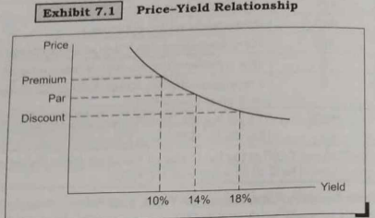

# Explain the types of working capital. Explain operating cycle with diagram.

There are two concepts of working capital:

1. Gross working Capital

It is the capital that is invested in the current assets of the company. Current assets are those assets which in the ordinary course of business can be converted into cash within a short period of normally one accounting year.

Examples of Current Assets:

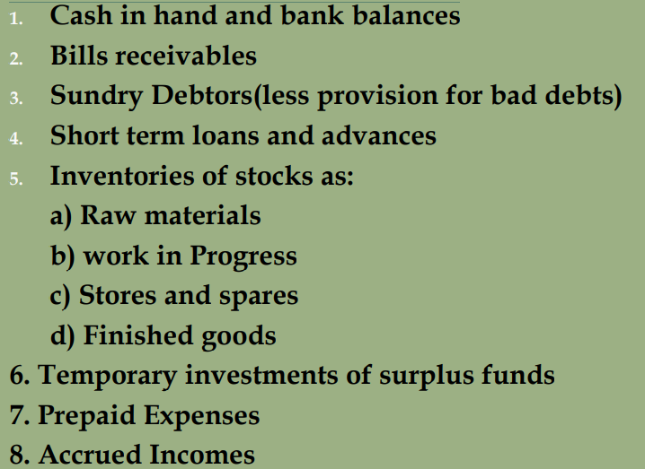

1. Net working Capital

In a narrow sense the term net working capital refers to the excess of current assets over current liabilities:

Net working Capital= Current assets – Current Liabilities

Examples of Current liabilities:

**Working Capital Cycle**